Easyfundraising Partnership

What is easy fundraising?
Easyfundraising is the UK’s BIGGEST charity shopping fundraising site, what will help you hit your fundraising target!
With easyfundraising, you get FREE cash-back donations towards the cost of your challenge whenever you, your family & friends shop online with over 3,500 big-name retailers including Amazon, eBay, John Lewis, ASOS, Sainsbury’s, Booking.com, TUI, Trainline & Just Eat!

How can I do it?
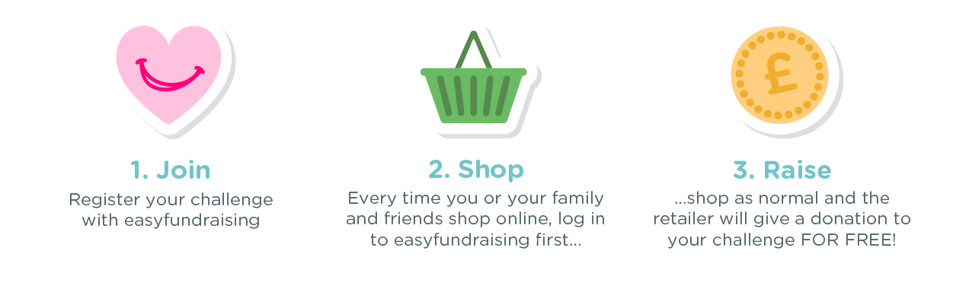
All you need to do is register your challenger as a good cause with easyfundraising at https://www.easyfundraising.org.uk/mrf (it’s free!) and you can start raising donations to help defeat meningitis wherever it exists!

Instructions
1. Sign-up: register your challenge with easyfundraising & say how you want to receive your donations - by cheque or bank transfer.
2. Shop: ask your family and friends to use the easyfundraising website every time they want to shop online - there are over 3,500 retailers to choose from Amazon to ASOS
3. Raise: when they buy something, the retailer will send you a FREE cashback donation more than ever.

