Sweepstake entrant | Time 00:00:00 (nearest wins!)
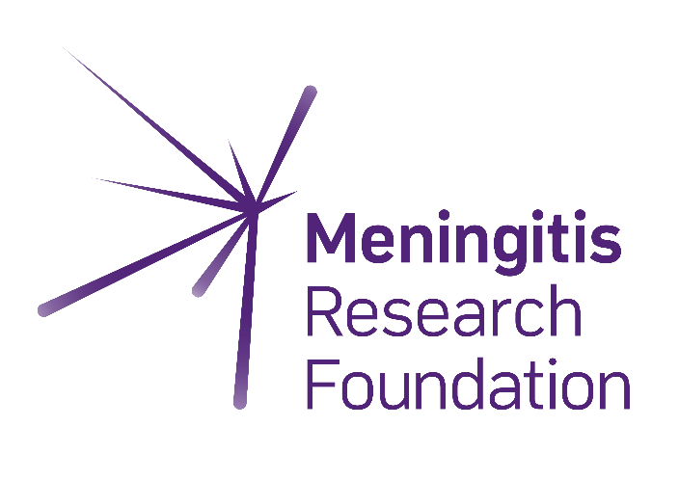
Thank you
for making a difference
Meningitis Research Foundation is a leading UK meningitis charity that brings together people and expertise to defeat meningitis and septicaemia wherever they exist.
For every 10 people affected by this disease, 1 will die and 2 will be left with life-altering after-effects such as limb loss, brain damage, and hearing or sight loss.
We invest in research, raise awareness and provide support for those who have been affected by this disease.
Together we will defeat meningitis.
Name of participant
I’m doing:

Challenge details
How to play:
- Ask your friends or colleagues to guess your time (no repetition allowed!)
- Keep a record of everyone’s guesses on this poster.
- After your challenge, present the winner with a prize and donate the money raised to Meningitis Research Foundation.
Please read the guidelines in our Sweepstakes guide before hosting your own sweepstake.
£2*
*suggested entry
Can you
GUESS MY TIME?
Host our fun sweepstake with your friends, family, or in your workplace to help us achieve our goal of a world free from meningitis and septicaemia.

