Great Manchester Run

Join us for Europe's largest 10K run at the Great Manchester Run 2020
The Great Manchester Run is host to the largest 10K run in the whole of Europe and the event is set to be even bigger and better than ever!
The combination of crowds, fancy dress and elation of over 30,000 runners surrounding you will be more than enough to keep you running through the streets of Manchester and crossing that all important finish line.
Join #TeamMRF and take part in this incredible event to run for a world free from meningitis.

When: 24th May 2020
Where: Manchester

Fundraising Target 10K: £150
Fundraising Target Half: £300

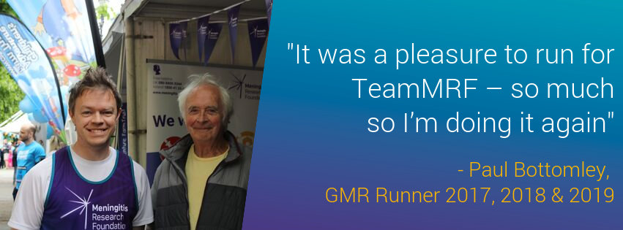
All of our runners can expect to receive:
- Training and fundraising guide
- Meningitis Research Foundation running vest
- Award-winning fundraising support from Erin, your dedicated charity contact
- Regular updates throughout the year to keep you informed of everything you need to know
- Access to our #TeamMRF Facebook group so you can get to know and support your fellow runners, and celebrate each others training/fundraising achievements!

