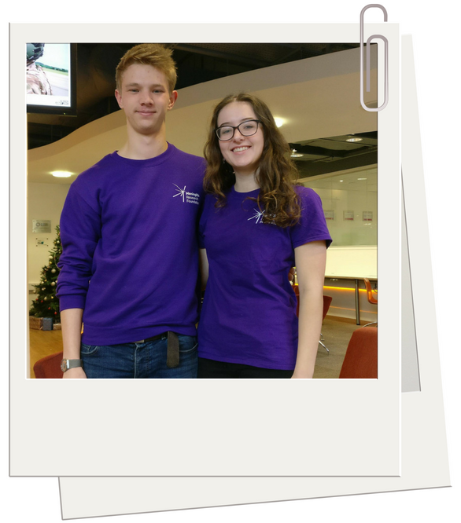
Case Study: Adam and Elisha (Carnival RAG)

What they did
- Adam and Elisha did an amazing job of getting their team to socialise and bond with one another, which can often be one of the hardest parts of being a Challenge Leader.

How they did it
Socials:
- Their first social was a sober one; they organised a meal at an Indian restaurant that offered a discount for students to ensure it was inclusive to everyone. A sober event is a great idea for a first social, as going on a night out with a group of strangers can be quite intimidating. That said, after the meal they went on to a pub and then into town for a night out for those who wanted to.
- After the first social, Adam and Elisha (and later others in the team, too) would organise a night out at least once a month.
- They also organised another sober social later in the year, where they had a movie night at someone’s house and ordered pizza.
“I think the main reason everyone bonded so well was due to the initial sober meal out. From there people knew each other and those that didn’t know anyone originally would then go with someone they met at the meal to other events” Adam

Workshops:
- Adam and Elisha also delivered the termly workshops provided by MRF and Choose a Challenge, which not only helped the team to come up with some group fundraising ideas and stay up to date with information relating to their trip, but this was yet another opportunity for the team to get to know one another.
- In addition, after any meetings (such as these workshops, or the welcome meeting or pre-departure briefing) they would encourage the team to join them for a drink at the on-campus bar.
“We would go to the bar after any meetings, e.g. the fundraising workshops, and this was a good chance for people that hadn’t been a social before to feel less awkward about coming as we all went together from the meeting” Elisha

Collections:
- They would also get the team together for lunch at bucket collections, too. This is a fantastic idea, but always make sure you arrange these breaks outside of the busy lunch period in order to avoid missing out on donations!
- It’s also a really good idea to arrange a meeting time/place or to arrange transport together, especially at the first couple of street collections. Going to a collection for the first time can be daunting for a lot of people, so going with others and having lunch with the rest of your team can make it a lot less intimidating.

The impact
- A social team is a happy team! By getting everyone to socialise with their fellow team members, people were more invested in taking part in the challenge – i.e. now not only did they want to climb Kilimanjaro, they wanted to do so with the rest of their team. This meant that people were less likely to drop out of the challenge or defer their place until next year.
- It also meant that the team shared fundraising ideas with one another and supported each other with their fundraising, too. Several members of the team organised really successful events, which they shared with the rest of the team and other members then replicated as a result – helping them all to smash their fundraising targets!

