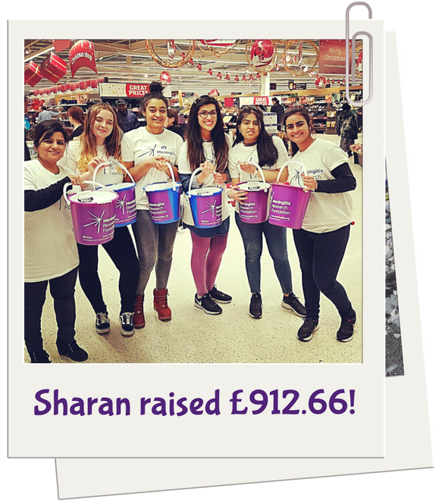
Bag Pack

Getting ready for the event
- Organise the collection – The best way to organise a bag pack is to go in person with your letter of authority and ask to speak to the general manager. Alternatively, use our template letter to write to them instead. If you don’t hear back straight away, don’t be afraid to be persistent and keep calling/emailing until you get a response. As it’s a popular fundraising activity, slots can get booked up a few months in advance so you’ll need to plan ahead. You might be able to book more than one date at a time.
- Organise your volunteers – Find out how many tills will be open and organize for that many members of your team to be present. If there are more people than there are tills, create a rota so that everyone gets a chance to take part.

What you’ll need
- Buckets
- T-shirts

On the day
Ask each customer if they’d like you to pack their bags. Remember to put frozen items and cleaning products separately, and put heavier items in first and fragile items on top.
People will donate however much they like, just have your bucket clearly displayed and let people know what you’re fundraising for.
Have a plan for how you’ll get home with buckets full of change – think about security. It would be best if you’re able to drive straight home.

Post event
Ensure that each member of your team counts and banks there money as soon as possible after the event. Inform MRF of the total amount raised so that they can send the store a certificate and letter of thanks.

Top tips
- Try to book the biggest supermarket and ask the manager to book you in at busy times of day to try and raise as many donations as you can

[RECIPIENT’S NAME]
[RECIPIENT’S ADDRESS]
[TODAY’S DATE]

[YOUR NAME]
[YOUR ADDRESS]

Dear [RECIPIENT’S NAME],

I am writing to you regarding a proposed Bag Pack fundraiser.

My name is [YOUR NAME] and I am a student at UNIVERSITY. In MONTH 2018 I will be undertaking CHALLENGE, as part of a project run by UNIVERSITY Raise and Give (RAG), raising money for Meningitis Research Foundation (registered charity no. 1091105). I am tasked with fundraising TARGET for the charity through this challenge, and am fundraising throughout the academic year to do so. Therefore, I would like to request a bag packing date on the nearest available Saturday at your store. I would be grateful if you could get back to me as soon as possible with the closest proposed date and how many available places there are for bag packing.

The dates I would be available are:
- Date 1
- Date 2
- Date 3

The money raised at this bag pack would go towards the work of Meningitis Research Foundation, who are fighting to create a world free of meningitis and septicaemia. Students are the second largest at risk group (after babies and toddlers), which is why, as a student, this charity appealed to me as a particularly worthy cause. The money that your customers donate to this amazing charity will spent on conducting research into prevention detection and treatment of the disease; raising awareness of meningitis and its symptoms and the available vaccinations etc.; and providing support for those who have been affected by the disease. Please find attached a letter from the charity authorizing me to fundraise on their behalf.

If you have any questions about the KILIMANJARO/EVEREST/MARATHON challenge or the charity, or if you would just like to find out more, please contact me at [YOUR EMAIL ADDRESS] or on [YOUR PHONE NUMBER].

Thank you kindly for taking the time to read about my project; I look forward to hearing from you soon.

Yours sincerely,

[YOUR SIGNATURE]

[YOUR NAME]

