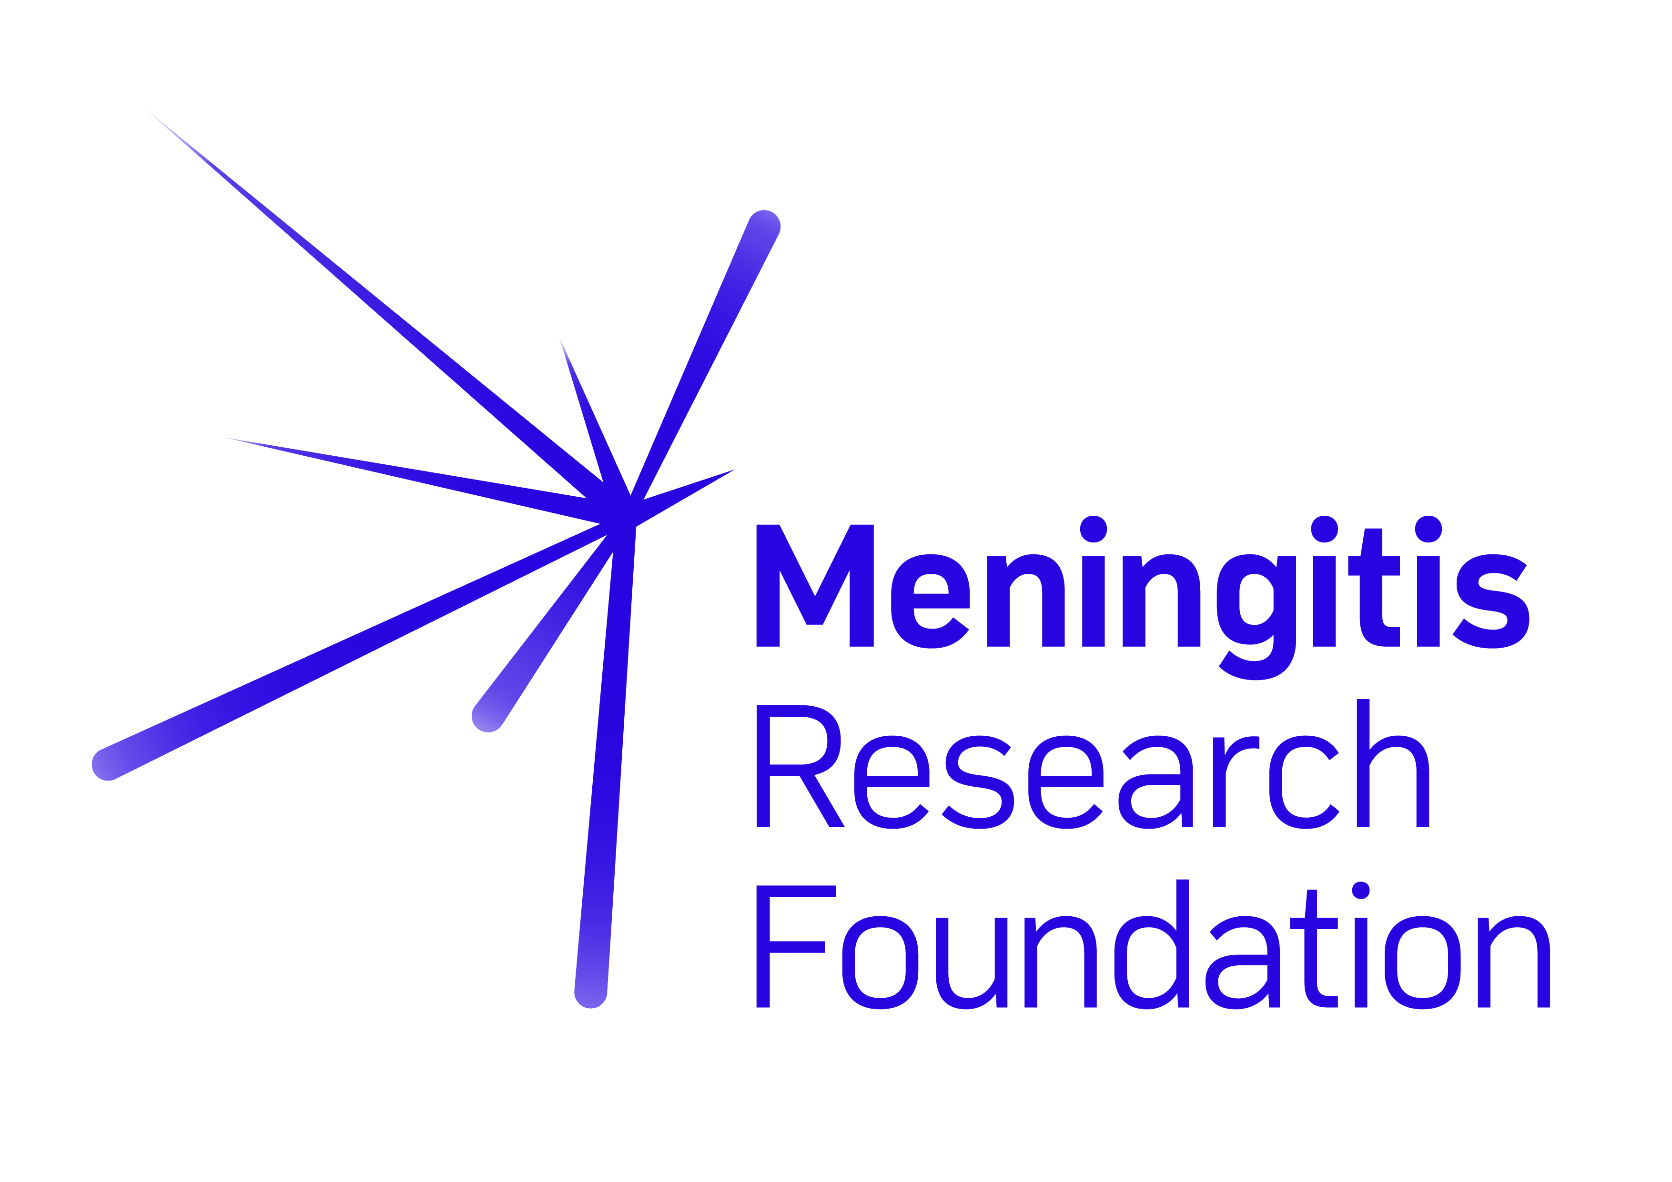
Donation Form

To make a donation, please print off this form, fill it in, and post it to your nearest Meningitis Research Foundation office:

England and Wales

Newminster House

Baldwin Street

Bristol BS1 1LT

Scotland
One St Colme Street
Edinburgh EH3 6AA
Northern Ireland
71 Botanic Avenue Belfast BT7 1JL
Ireland
64-66 Lower Gardiner Street Dublin 1

I enclose a cheque/postal order/CAF voucher for: (Please make payable to Meningitis Research Foundation)

OR Please debit my credit/debit card as follows:

£ GBP / € Euros

Donation Amount
£ GBP / € Euro

Visa MasterCard American Express Switch/Maestro Solo

Card Number

Valid from Expiry Date

Last three digits of security code

Issue Number (Switch/Maestro/Solo only)

Signature Date

Title First Name Surname

Address

Postcode

Email Telephone

Please tick this box if you are happy to receive email and other electronic forms of communication from Meningitis Research Foundation

Do you have personal experience of meningitis and septicaemia?

If you have been bereaved as a result of these diseases let us know, and we can record the donation in their memory.

If you organised or took part in an event to raise
this money please let us know what you did.

Tax relief: make your gift worth more at no extra cost to you.
If you are a UK taxpayer, for every £1 you donate, we can claim a further 25p from the Inland Revenue.

I would like Meningitis Research Foundation to reclaim tax on all donations I have made within the last 4 years and on any donations
I make in the future. I am a UK tax payer.

Signature Date

Republic of Ireland PAYE donors: We can reclaim tax on donations of €250 and over, made by PAYE employees. Call the Dublin office on 01 819 6931.

Data protection: Meningitis Research Foundation will/may hold any information you provide. We never sell supporters’ details to other organisations. However, we would like to retain your details so that we can inform you about events and services offered by ourselves or selected third parties. This may be by post, telephone or e-mail. If you prefer not to receive these communications please tick the appropriate box below.

No future contact by Meningitis Research Foundation
No future contact by 3rd party partners

