Virtual Recruitment Guide

Recruitment will be looking very different for the time being. With minimal face-to-face promotion taking place, this guide will tell you just how to promote your trip effectively and build a fantastic team for the year ahead.
Social Media

Social media will be your new best friend over the coming weeks! Utilise all social platforms available to you…. Even Tiktok. You may want to split up the platforms if you have a partner leader. Remember, your aim is to reach as many people on your campus as possible. If people don’t know about the trip, they won’t sign up.

Facebook
Facebook Event: Choose a Challenge will create the information meeting Facebook event. You need to invite everyone you know. Enlist your housemates in sharing it far and wide to reach as many people as possible. Get in touch with sports clubs and societies and ask them to share to their members as well as publishing it on their own platforms.
Post a welcome message in the event introducing yourself. Videos work really well! Be positive and as engaging as possible. Don’t be afraid to throw in a few puns. Here is a fab example:
https://www.facebook.com/100001327687097/videos/2384579418262958/?extid=79xkDzQ85HUngumu.
Profile Pictures/ Cover Photos: Change your photos to your trip and info meeting dates. You can create frames and banners so you picture is still visible. Again, enlist the support of your own network by asking them to change their own profile and cover photos in support.

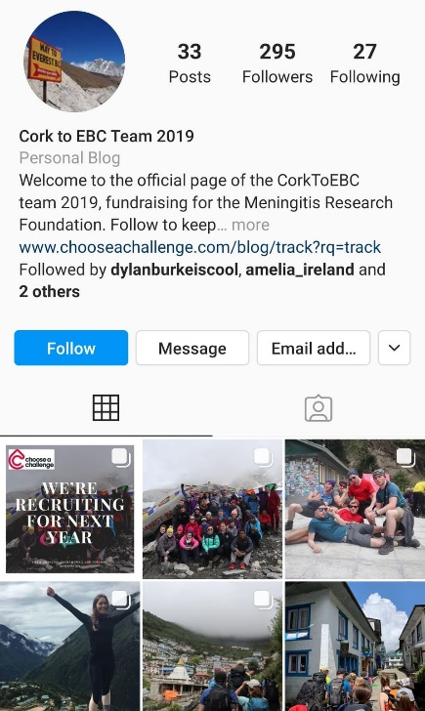
Instagram
You RAG may already have an Instagram account. However, if not then creating an account dedicated to your trip is a great way to not only aid your recruitment efforts, but also document your teams fundraising journey and ultimately the trip.
As the account grows, potential sign-ups will be able to scroll through previous years and see how much fun signing up will be. Include testimonials from past volunteers, and ask them to share any photographs they may have taken while fundraising or while on their trip. The ‘stories’ section is a fantastic way to be active during recruitment!

Snapchat
Just like Facebook, you can create your own filters on snapchat that advertise the time, date and location of your info talk (or in this case, the link to the webinar). Add posts to your location story so anyone in the area or campus can view it.

Tinder/Hinge/Bumble
You’re trying to reach as many people on campus as possible. So why not take your campaign to where many of them are? Tinder. As they are aimlessly scrolling through, hoping for a match, they will come across your Challenge Profile advertising the trip of a lifetime. Remember to sell the trip in the bio as well as all the fundraising support on offer all year round.
Once you have a match, this is your time to pitch your challenge! Give them all the key info and important upcoming dates. Explain the fundraising support and feel free to pass on the students@meningitis.org email if they would like to get in touch.
Top tip: You have to add a picture of yourself to the profile, as Tinder will delete any profiles without one.

Slides During Lectures
Creating an Elevator Pitch in the form of a slide about your trip will help you reach people without speaking to them face to face. Email all University faculty members asking their permission to show it before their lecture or during the break. Include the link to the Facebook event, a picture of yourself, as well as your contact details/social media.

Faculty Wide Emails
Asking faculties to send out an email to all their students is a great way of reaching lots of people with minimal effort. Although sending out emails to every faculty won’t hurt, it’s always good to target the student who you know are likely to sign up. These include Psychology, Primary Education and Geography etc. Include links to the Facebook event and your contact details incase people have questions.

Virtual Fresher Fairs
In many cases, fairs are still happening, just via zoom. You may need to book in via your SU or Volunteering department. Attending these fairs will enable to you speak to people who are actively seeking to get involved in something and not just going for the free pens.

Top Tips
- Have fun with it! You are giving students an amazing opportunity for a great cause
- Use your extended network to help promote your trip and invite to the event
- Use your RAG’s support, knowledge and resources – they know their stuff!

